RW Shielding Results

Setup
I’m using UPPAAL 4.1.20-stratego-10-beta1 with a shield imported as a C library. (Commit 15478c89.)
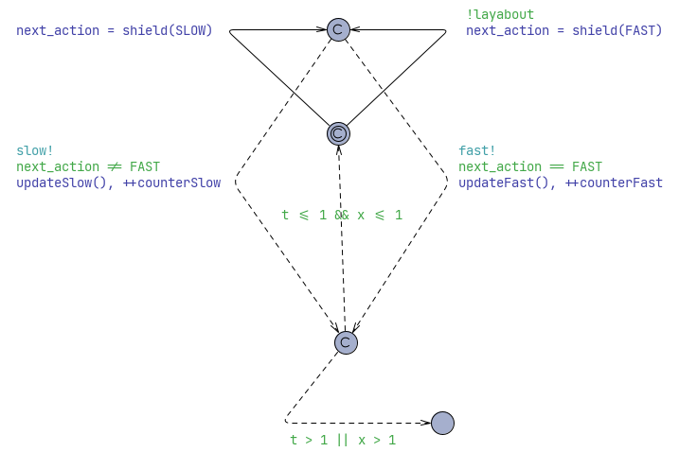
Notice the !layabout guard. It is a constant bool, which allows me to force the player to only take the slow action. That way, I can test the layabout shield strategy.
Another flag I coded is the constant bool unlucky, which simulates the worst-case behaviour.

Validation of the shield
I can check that the simulation, the shield and the cost functions all match between the UPPAAL model and the Pluto notebook, by cross-checking their average scores. Using a shielded layabout strategy with both, I will compute the average score of a run and see if they match.
Cost function: parabola_x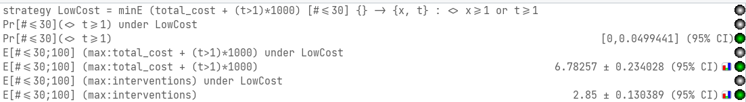
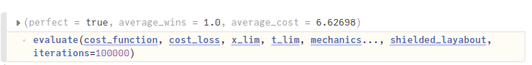I see that the average cost just about matches. Very nice.
Cost function: sinus_x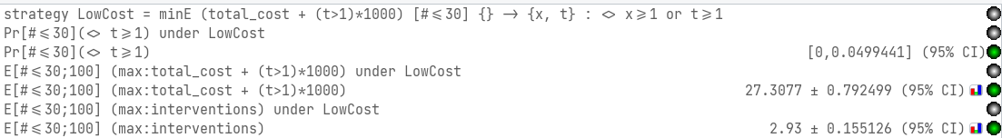
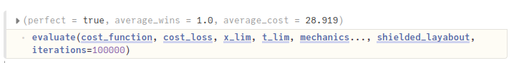These two values are pretty close to matching as well. There is a slight, inexplicable difference in results though.
Also note that in both screenshots, the chance of reaching t>1 is between 0.0 and 0.5. This is an indication that the shield is indeed safe. The possiblitity of the chance being 0.0 means that no safety violations were observed.
I can also check that the shield works in the worst case:
And it sure seems that it does.

Unshielded
I set the cost of losing to be 1000, and learn a strategy to minimize cost.
Cost function: parabola_x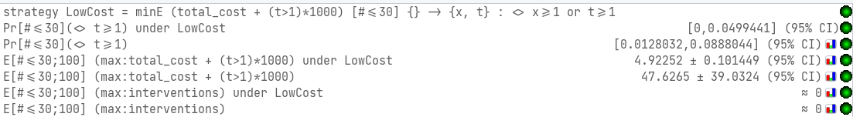
Cost function: sinus_x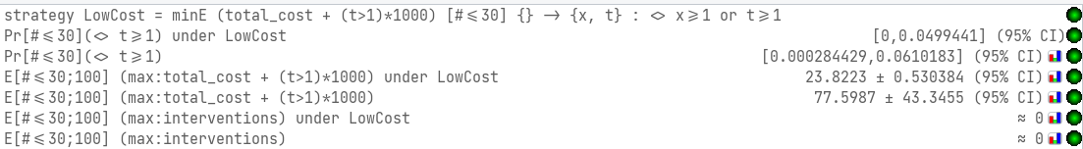
In both cases, it fares better than the random agent. It also fares slightly better than the shielded layabout when the parabola cost function is used. No significant change to the sinus function however.
The random agent is observed to have some small chance of violating the safety property, while it seems the learned strategy is good at avoidig it. No safety violation observed in the random runs.
However, I can also check if the learned strategy is able to deal with the worst-case. And it is not:
So the worst case is a witness trace that the unshielded strategy is unsafe.

Post-shielded
Time to have a look at post-shielding. I train the strategy with the shield disabled, save it, and then load it when the shield has been enabled again. Let’s go.
Cost function: parabola_x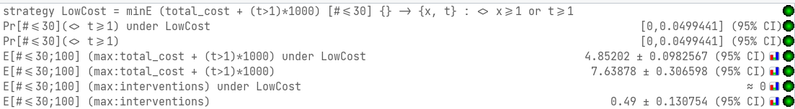
Cost function: sinus_x 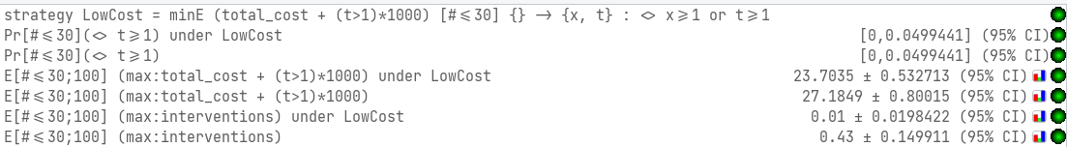
That’s wild. The shield nearly doesn’t interfere at all. The shield was not observed to interfere with the strategy developed for the parabola strategy at all, and only minimaly with the sinus cost function strategy. No significant change in the score was observed from this.

Pre-shielded
And now for pre-shielding. Shield active during training. Let’s go.
Cost function: parabola_x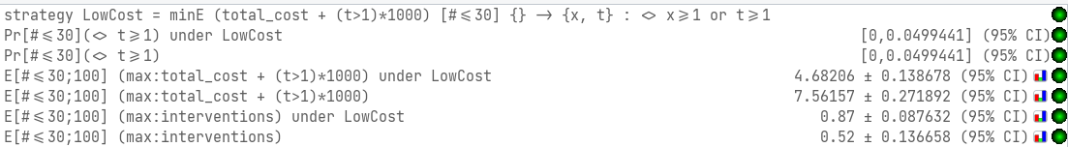
Cost function: sinus_x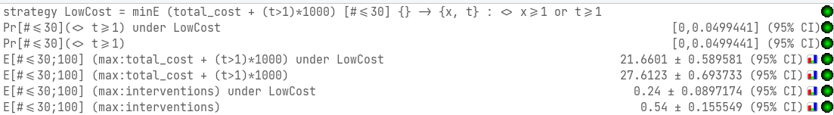
No significat improvement.

